SPRINT 1

|  |  |
| --- | --- |
| DATE | 24 OCTOBER 2022 |
| TEAM ID | PNT2022TMID33663 |
| PROJECT NAME | IOT BASED SMART CROP PROTECTION SYSTEM IN AGRICULTURE |
| MAXIMUM MARKS | 20 MARKS |

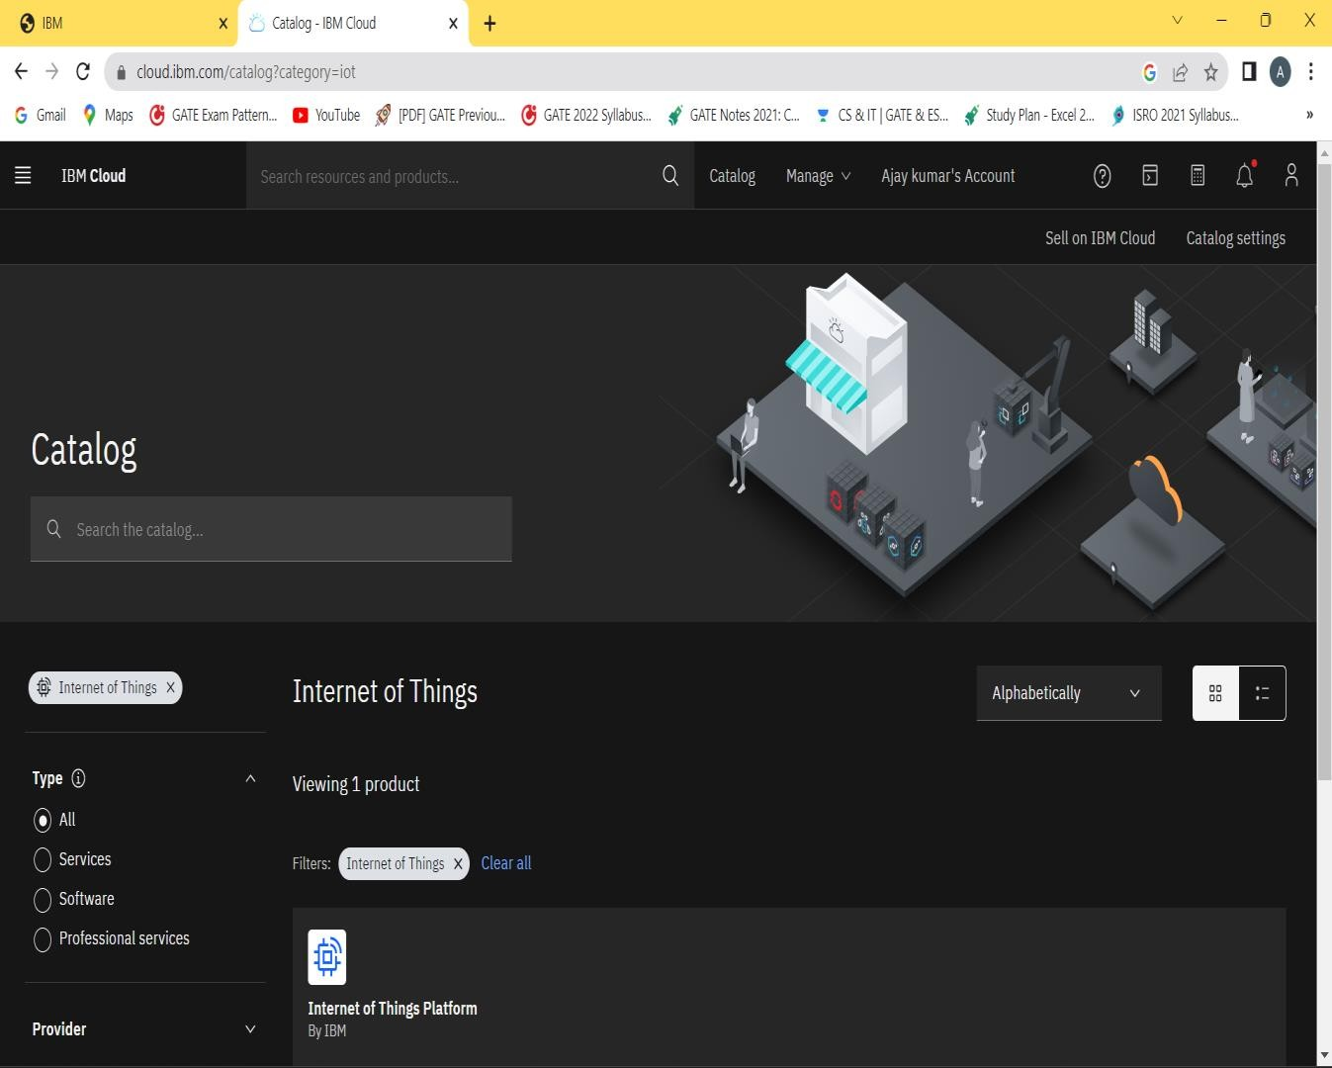

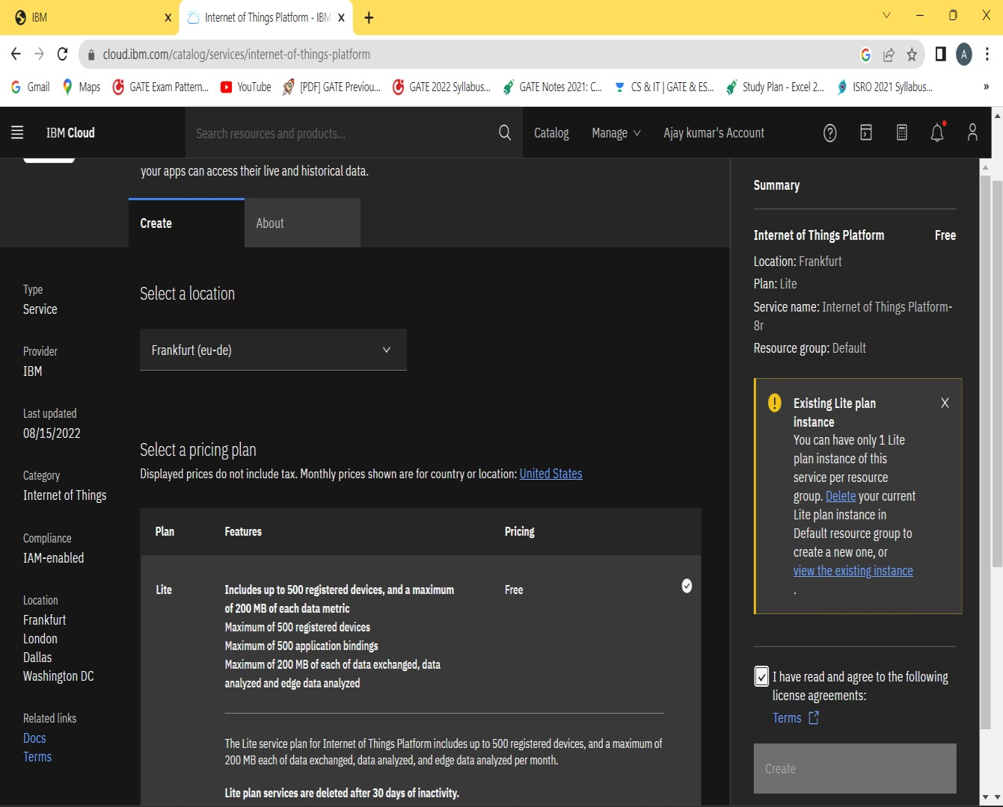

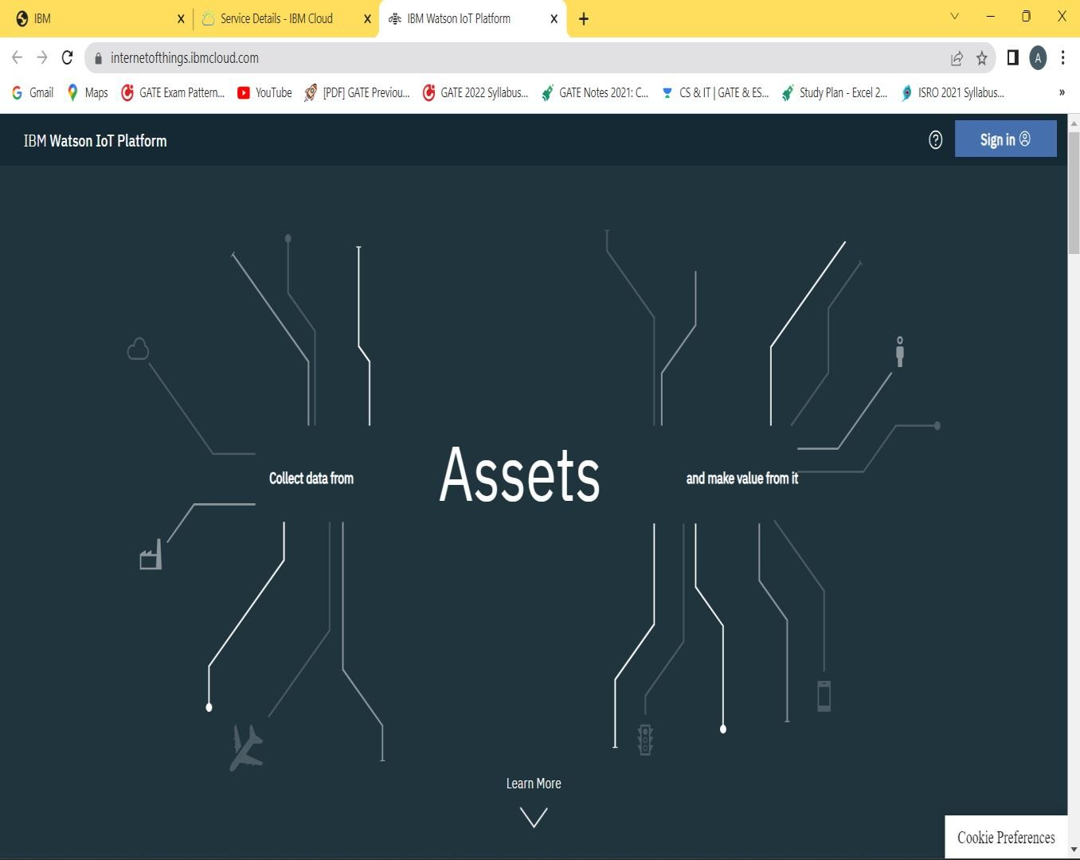

DEVICE CREDENTIALS INFORMATION:

